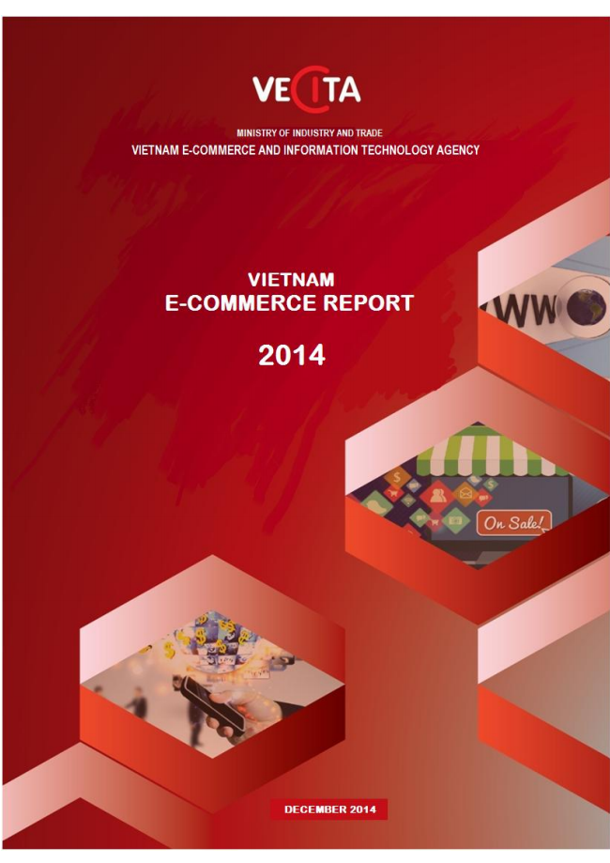

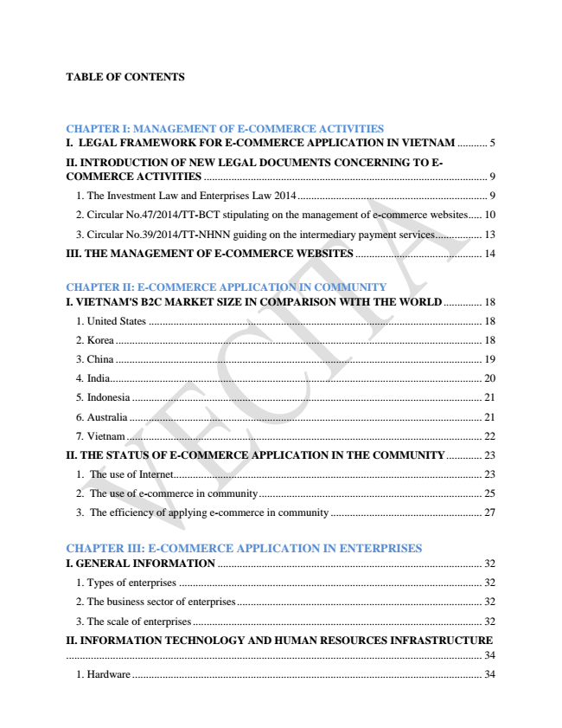

**TABLE OF CONTENTS**

**CHAPTER I: MANAGEMENT OF E-COMMERCE ACTIVITIES I. LEGAL FRAMEWORK FOR E-COMMERCE APPLICATION IN VIETNAM ........... 5**

II. INTRODUCTION OF NEW LEGAL DOCUMENTS CONCERNING TO E- COMMERCE ACTIVITIES ....................................................................................................... 9

1. The Investment Law and Enterprises Law 2014 ..................................................................... 9

2. Circular No.47/2014/TT-BCT stipulating on the management of e-commerce websites..... 10

3. Circular No.39/2014/TT-NHNN guiding on the intermediary payment services ................. 13

III. THE MANAGEMENT OF E-COMMERCE WEBSITES .............................................. 14

**CHAPTER II: E-COMMERCE APPLICATION IN COMMUNITY I. VIETNAM'S B2C MARKET SIZE IN COMPARISON WITH THE WORLD .............. 18**

1. United States ......................................................................................................................... 18

2. Korea ..................................................................................................................................... 18

3. China ..................................................................................................................................... 19

4. India ....................................................................................................................................... 20

5. Indonesia ............................................................................................................................... 21

6. Australia ................................................................................................................................ 21

7. Vietnam ................................................................................................................................. 22

**II. THE STATUS OF E-COMMERCE APPLICATION IN THE COMMUNITY ............. 23**

1. The use of Internet................................................................................................................ 23

2. The use of e-commerce in community ................................................................................. 25

3. The efficiency of applying e-commerce in community ....................................................... 27

CHAPTER III: E-COMMERCE APPLICATION IN ENTERPRISES I. GENERAL INFORMATION ................................................................................................ 32

1. Types of enterprises .............................................................................................................. 32

2. The business sector of enterprises ......................................................................................... 32

3. The scale of enterprises ......................................................................................................... 32

II. INFORMATION TECHNOLOGY AND HUMAN RESOURCES INFRASTRUCTURE ....................................................................................................................................................... 34

1. Hardware ............................................................................................................................... 34

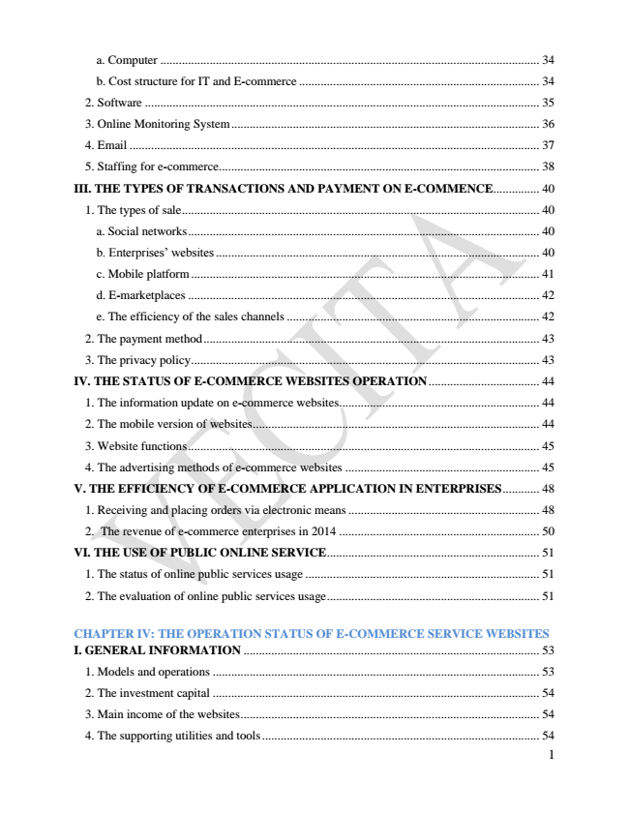

a. Computer ........................................................................................................................... 34

b. Cost structure for IT and E-commerce .............................................................................. 34

2. Software ................................................................................................................................ 35

3. Online Monitoring System .................................................................................................... 36

4. Email ..................................................................................................................................... 37

5. Staffing for e-commerce........................................................................................................ 38

**III. THE TYPES OF TRANSACTIONS AND PAYMENT ON E-COMMENCE ............... 40**

1. The types of sale .................................................................................................................... 40

a. Social networks .................................................................................................................. 40

b. Enterprises’ websites ......................................................................................................... 40

c. Mobile platform ................................................................................................................. 41

d. E-marketplaces .................................................................................................................. 42

e. The efficiency of the sales channels .................................................................................. 42

2. The payment method ............................................................................................................. 43

3. The privacy policy ................................................................................................................. 43

**IV. THE STATUS OF E-COMMERCE WEBSITES OPERATION .................................... 44**

1. The information update on e-commerce websites................................................................. 44

2. The mobile version of websites ............................................................................................. 44

3. Website functions .................................................................................................................. 45

4. The advertising methods of e-commerce websites ............................................................... 45

**V. THE EFFICIENCY OF E-COMMERCE APPLICATION IN ENTERPRISES ............ 48**

1. Receiving and placing orders via electronic means .............................................................. 48

2. The revenue of e-commerce enterprises in 2014 ................................................................. 50

VI. THE USE OF PUBLIC ONLINE SERVICE ..................................................................... 51

1. The status of online public services usage ............................................................................ 51

2. The evaluation of online public services usage ..................................................................... 51

CHAPTER IV: THE OPERATION STATUS OF E-COMMERCE SERVICE WEBSITES I. GENERAL INFORMATION ................................................................................................ 53

1. Models and operations .......................................................................................................... 53

2. The investment capital .......................................................................................................... 54

3. Main income of the websites ................................................................................................. 54

4. The supporting utilities and tools .......................................................................................... 54

1

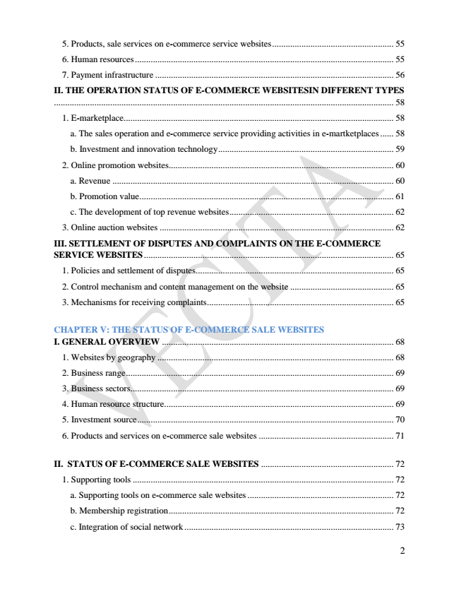

5. Products, sale services on e-commerce service websites ...................................................... 55

6. Human resources ................................................................................................................... 55

7. Payment infrastructure .......................................................................................................... 56

II. THE OPERATION STATUS OF E-COMMERCE WEBSITESIN DIFFERENT TYPES ....................................................................................................................................................... 58

1. E-marketplace........................................................................................................................ 58

a. The sales operation and e-commerce service providing activities in e-martketplaces ...... 58

b. Investment and innovation technology .............................................................................. 59

2. Online promotion websites.................................................................................................... 60

a. Revenue ............................................................................................................................. 60

b. Promotion value ................................................................................................................. 61

c. The development of top revenue websites ......................................................................... 62

3. Online auction websites ........................................................................................................ 62

III. SETTLEMENT OF DISPUTES AND COMPLAINTS ON THE E-COMMERCE SERVICE WEBSITES ............................................................................................................... 65

1. Policies and settlement of disputes........................................................................................ 65

2. Control mechanism and content management on the website .............................................. 65

3. Mechanisms for receiving complaints................................................................................... 65

CHAPTER V: THE STATUS OF E-COMMERCE SALE WEBSITES I. GENERAL OVERVIEW ....................................................................................................... 68

1. Websites by geography ......................................................................................................... 68

2. Business range ....................................................................................................................... 69

3. Business sectors..................................................................................................................... 69

4. Human resource structure...................................................................................................... 69

5. Investment source .................................................................................................................. 70

6. Products and services on e-commerce sale websites ............................................................ 71

II. STATUS OF E-COMMERCE SALE WEBSITES ........................................................... 72

1. Supporting tools .................................................................................................................... 72

a. Supporting tools on e-commerce sale websites ................................................................. 72

b. Membership registration .................................................................................................... 72

c. Integration of social network ............................................................................................. 73

2

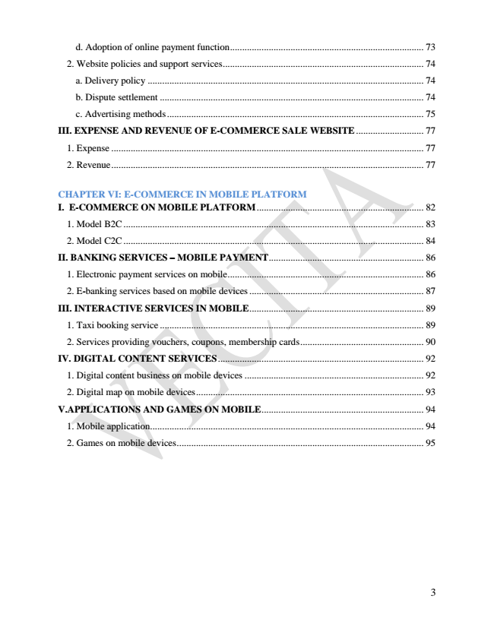

d. Adoption of online payment function ................................................................................ 73

2. Website policies and support services ................................................................................... 74

a. Delivery policy .................................................................................................................. 74

b. Dispute settlement ............................................................................................................. 74

c. Advertising methods .......................................................................................................... 75

**III. EXPENSE AND REVENUE OF E-COMMERCE SALE WEBSITE ............................ 77**

1. Expense ................................................................................................................................. 77

2. Revenue ................................................................................................................................. 77

CHAPTER VI: E-COMMERCE IN MOBILE PLATFORM I. E-COMMERCE ON MOBILE PLATFORM ..................................................................... 82

1. Model B2C ............................................................................................................................ 83

2. Model C2C ............................................................................................................................ 84

II. BANKING SERVICES – MOBILE PAYMENT ................................................................ 86

1. Electronic payment services on mobile ................................................................................. 86

2. E-banking services based on mobile devices ........................................................................ 87

III. INTERACTIVE SERVICES IN MOBILE ........................................................................ 89

1. Taxi booking service ............................................................................................................. 89

2. Services providing vouchers, coupons, membership cards ................................................... 90

IV. DIGITAL CONTENT SERVICES ..................................................................................... 92

1. Digital content business on mobile devices .......................................................................... 92

2. Digital map on mobile devices .............................................................................................. 93

V.APPLICATIONS AND GAMES ON MOBILE ................................................................... 94

1. Mobile application................................................................................................................. 94

2. Games on mobile devices ...................................................................................................... 95

3



**CHAPTER I**

**MANAGEMENT OF E-COMMERCE ACTIVITIES**

4

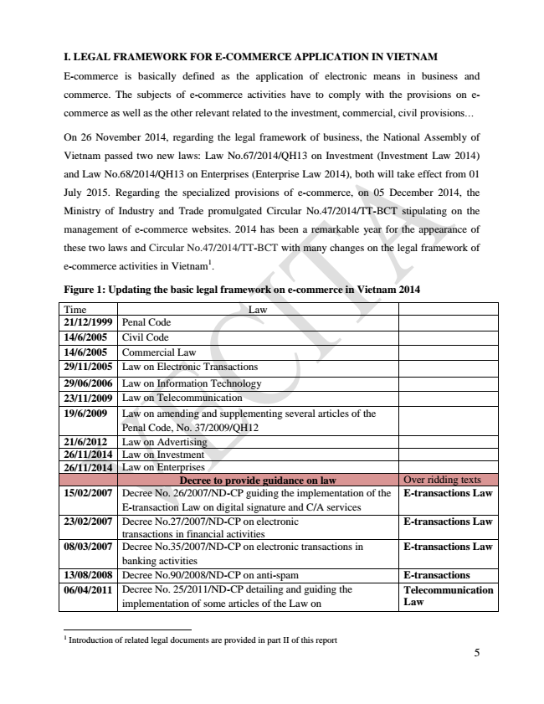

**I. LEGAL FRAMEWORK FOR E-COMMERCE APPLICATION IN VIETNAM**

E-commerce is basically defined as the application of electronic means in business and

commerce. The subjects of e-commerce activities have to comply with the provisions on e-

commerce as well as the other relevant related to the investment, commercial, civil provisions...

On 26 November 2014, regarding the legal framework of business, the National Assembly of

Vietnam passed two new laws: Law No.67/2014/QH13 on Investment (Investment Law 2014)

and Law No.68/2014/QH13 on Enterprises (Enterprise Law 2014), both will take effect from 01

July 2015. Regarding the specialized provisions of e-commerce, on 05 December 2014, the

Ministry of Industry and Trade promulgated Circular No.47/2014/TT-BCT stipulating on the

management of e-commerce websites. 2014 has been a remarkable year for the appearance of

these two laws and Circular No.47/2014/TT-BCT with many changes on the legal framework of

e-commerce activities in Vietnam

1

.

**Figure 1: Updating the basic legal framework on e-commerce in Vietnam 2014**

Time Law 21/12/1999 Penal Code 14/6/2005 Civil Code 14/6/2005 Commercial Law 29/11/2005 Law on Electronic Transactions 29/06/2006 Law on Information Technology 23/11/2009 Law on Telecommunication 19/6/2009 Law on amending and supplementing several articles of the

Penal Code, No. 37/2009/QH12 21/6/2012 Law on Advertising 26/11/2014 Law on Investment 26/11/2014 Law on Enterprises

Decree to provide guidance on law Over ridding texts 15/02/2007 Decree No. 26/2007/ND-CP guiding the implementation of the

E-transaction Law on digital signature and C/A services

**E-transactions Law**

23/02/2007 Decree No.27/2007/ND-CP on electronic

transactions in financial activities

**E-transactions Law**

08/03/2007 Decree No.35/2007/ND-CP on electronic transactions in

banking activities

**E-transactions Law**

13/08/2008 Decree No.90/2008/ND-CP on anti-spam E-transactions 06/04/2011 Decree No. 25/2011/ND-CP detailing and guiding the

implementation of some articles of the Law on

**Telecommunication Law**

1 Introduction of related legal documents are provided in part II of this report

5

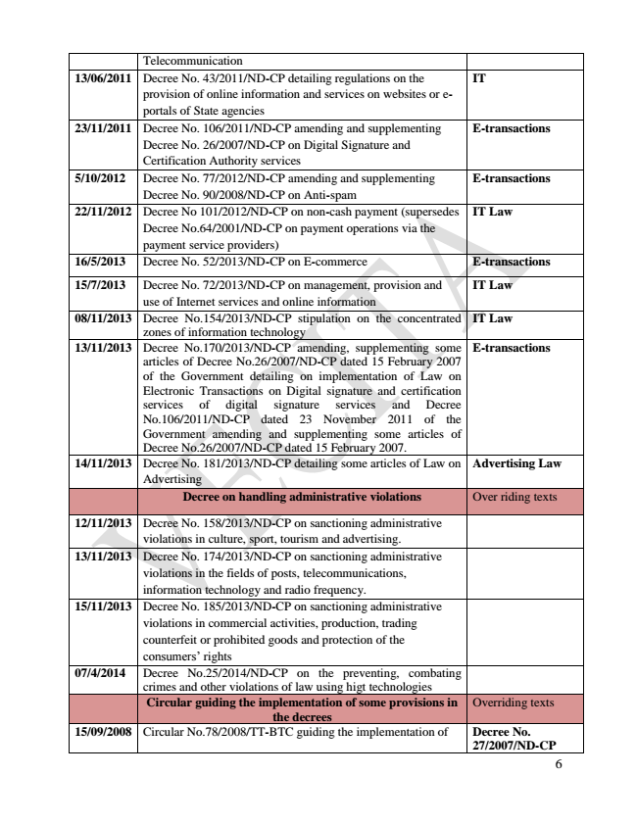

Telecommunication 13/06/2011 Decree No. 43/2011/ND-CP detailing regulations on the

provision of online information and services on websites or e- portals of State agencies

**IT**

23/11/2011 Decree No. 106/2011/ND-CP amending and supplementing

Decree No. 26/2007/ND-CP on Digital Signature and Certification Authority services

**E-transactions**

5/10/2012 Decree No. 77/2012/ND-CP amending and supplementing

Decree No. 90/2008/ND-CP on Anti-spam

**E-transactions**

22/11/2012 Decree No 101/2012/ND-CP on non-cash payment (supersedes

Decree No.64/2001/ND-CP on payment operations via the payment service providers)

**IT Law**

16/5/2013 Decree No. 52/2013/ND-CP on E-commerce E-transactions

15/7/2013 Decree No. 72/2013/ND-CP on management, provision and use of Internet services and online information

**IT Law**

08/11/2013 Decree No.154/2013/ND-CP stipulation on the concentrated

zones of information technology

**IT Law**

13/11/2013 Decree No.170/2013/ND-CP amending, supplementing some articles of Decree No.26/2007/ND-CP dated 15 February 2007 of the Government detailing on implementation of Law on Electronic Transactions on Digital signature and certification services of digital signature services and Decree No.106/2011/ND-CP dated 23 November 2011 of the Government amending and supplementing some articles of Decree No.26/2007/ND-CP dated 15 February 2007.

**E-transactions**

14/11/2013 Decree No. 181/2013/ND-CP detailing some articles of Law on

Advertising

**Advertising Law**

**Decree on handling administrative violations Over riding texts**

12/11/2013 Decree No. 158/2013/ND-CP on sanctioning administrative

violations in culture, sport, tourism and advertising. 13/11/2013 Decree No. 174/2013/ND-CP on sanctioning administrative

violations in the fields of posts, telecommunications, information technology and radio frequency. 15/11/2013 Decree No. 185/2013/ND-CP on sanctioning administrative

violations in commercial activities, production, trading counterfeit or prohibited goods and protection of the consumers’ rights 07/4/2014 Decree No.25/2014/ND-CP on the preventing, combating

crimes and other violations of law using higt technologies

**Circular guiding the implementation of some provisions in the decrees**

Overriding texts

15/09/2008 Circular No.78/2008/TT-BTC guiding the implementation of Decree No.

**27/2007/ND-CP**

6

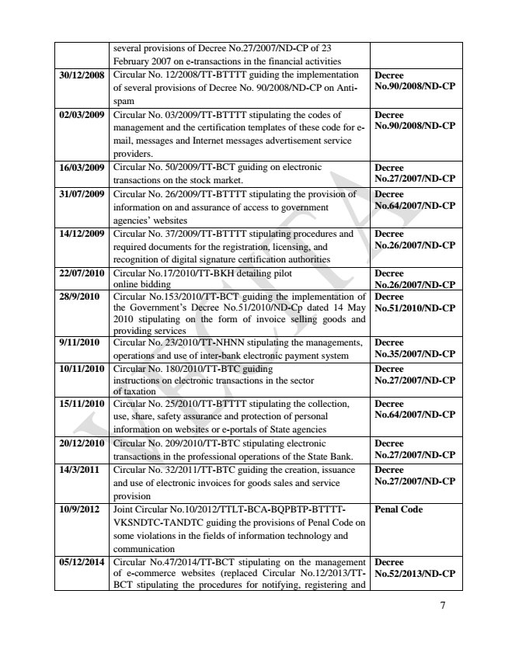

several provisions of Decree No.27/2007/ND-CP of 23 February 2007 on e-transactions in the financial activities 30/12/2008 Circular No. 12/2008/TT-BTTTT guiding the implementation of several provisions of Decree No. 90/2008/ND-CP on Anti- spam

**Decree No.90/2008/ND-CP**

02/03/2009 Circular No. 03/2009/TT-BTTTT stipulating the codes of

management and the certification templates of these code for e- mail, messages and Internet messages advertisement service providers.

**Decree No.90/2008/ND-CP**

16/03/2009 Circular No. 50/2009/TT-BCT guiding on electronic

transactions on the stock market.

Decree No.27/2007/ND-CP 31/07/2009 Circular No. 26/2009/TT-BTTTT stipulating the provision of

information on and assurance of access to government agencies’ websites

**Decree No.64/2007/ND-CP**

14/12/2009 Circular No. 37/2009/TT-BTTTT stipulating procedures and

required documents for the registration, licensing, and recognition of digital signature certification authorities

**Decree No.26/2007/ND-CP**

22/07/2010 Circular No.17/2010/TT-BKH detailing pilot

online bidding

Decree No.26/2007/ND-CP 28/9/2010 Circular No.153/2010/TT-BCT guiding the implementation of the Government’s Decree No.51/2010/ND-Cp dated 14 May 2010 stipulating on the form of invoice selling goods and providing services

**Decree No.51/2010/ND-CP**

9/11/2010 Circular No. 23/2010/TT-NHNN stipulating the managements,

operations and use of inter-bank electronic payment system

Decree No.35/2007/ND-CP 10/11/2010 Circular No. 180/2010/TT-BTC guiding

instructions on electronic transactions in the sector of taxation

**Decree No.27/2007/ND-CP**

15/11/2010 Circular No. 25/2010/TT-BTTTT stipulating the collection,

use, share, safety assurance and protection of personal information on websites or e-portals of State agencies

**Decree No.64/2007/ND-CP**

20/12/2010 Circular No. 209/2010/TT-BTC stipulating electronic

transactions in the professional operations of the State Bank.

Decree No.27/2007/ND-CP 14/3/2011 Circular No. 32/2011/TT-BTC guiding the creation, issuance

and use of electronic invoices for goods sales and service provision

**Decree No.27/2007/ND-CP**

10/9/2012 Joint Circular No.10/2012/TTLT-BCA-BQPBTP-BTTTT-

VKSNDTC-TANDTC guiding the provisions of Penal Code on some violations in the fields of information technology and communication

**Penal Code**

05/12/2014 Circular No.47/2014/TT-BCT stipulating on the management of e-commerce websites (replaced Circular No.12/2013/TT- BCT stipulating the procedures for notifying, registering and

**Decree No.52/2013/ND-CP**

7

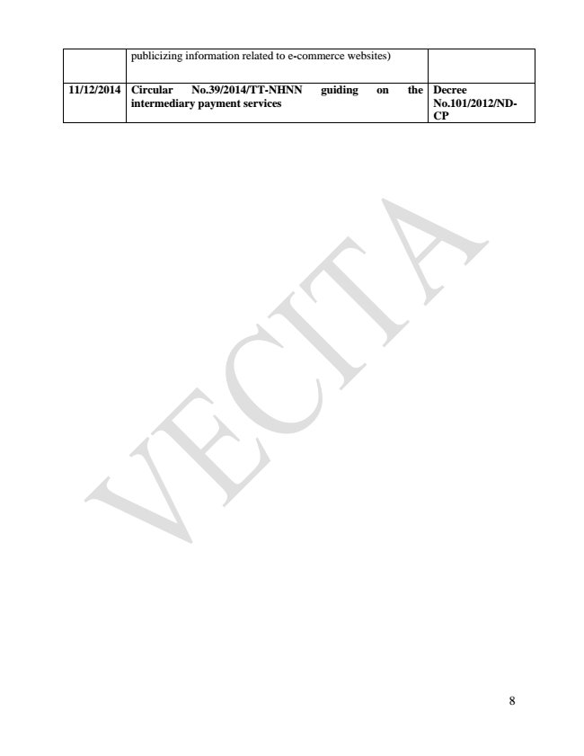

publicizing information related to e-commerce websites)

**11/12/2014 Circular No.39/2014/TT-NHNN guiding on the**

**intermediary payment services**

**Decree No.101/2012/ND- CP**

8